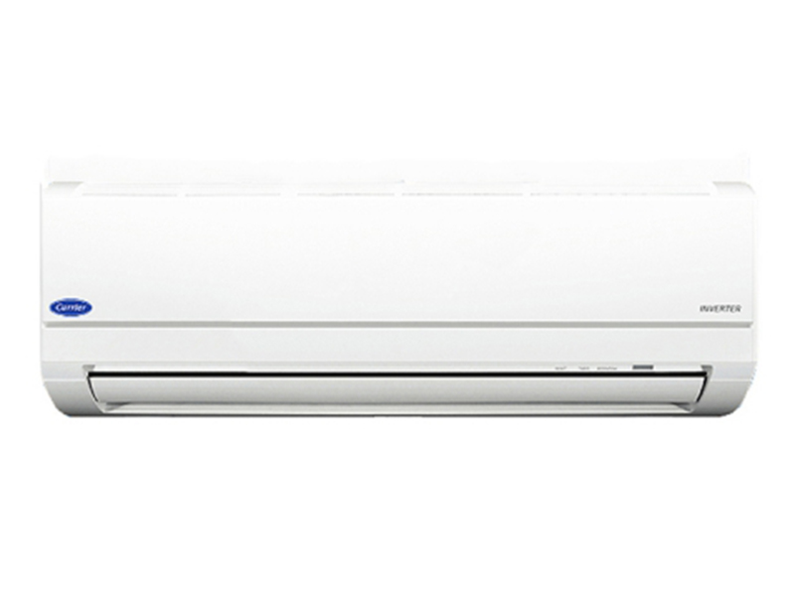

**8,030,000 VND**

**Air conditioner Carrier Inverter 38/42 GCVBE 010 9,000BTU Gas R32**

**Specifications**

* Usable area< 15m2
* Inverter technologyHave
* Maximum installation height between hot and cold units10m
* Copper pipe installation length20m
* Guarantee12 months
* Made inThailand
* Brand originAmerica

**Indoor unit parameters**

* Size of indoor unit740mm x 195mm x 250mm
* Volume of indoor unit8kg
* Cooling capacity9.000 BTU - 1HP

**Outdoor unit parameters**

* Size of outdoor unit598mm x 200mm x 530mm
* Mass of outdoor unit18kg
* Gas usedR32

## Carrier Inverter 38/42 GCVBE 010 air conditioner operates smoothly and cools quickly

**Carrier Inverter 38/42 GCVBE 010** is a [1-way air conditioner with 1HP cooling capacity](https://meta.vn/dieu-hoa-1-chieu-c1039?franges=1.91) suitable for use in rooms with an area of ​​15m2. The air conditioner has a traditional wall-mounted design.

**>> See details** : [Which country's Carrier air conditioners and air conditioners are good?](https://meta.vn/huong-dan/tu-van/danh-gia-may-lanh-dieu-hoa-carrier-8980)

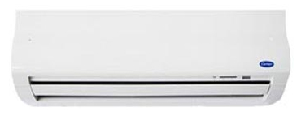

**Inverter technology**  helps the room reach the customized temperature fastest while still saving significant energy. In addition, [the air conditioner](https://meta.vn/dieu-hoa-c1018) also operates super quietly so you won't have to worry about it affecting your sleep.

**Fast cooling mode** because the air conditioner will operate at maximum capacity to cool, once the set temperature has been reached the machine will maintain and spread heat as desired by the user.

Effective **antibacterial ability because**[Carrier air conditioner](https://meta.vn/dieu-hoa-c1018?brands=2633) uses Nano Silver Ginseng and Nano Photo Copper filter technology, preventing bacteria, so the air in the room will be absolutely fresh.

**10 operating wind speeds** will help you choose to suit your needs. In addition, you can also adjust the wind direction up and down as desired.

**>> Reference** :  [How to use the air conditioner control, Carrier air conditioner remote](https://meta.vn/huong-dan/tu-van/cach-su-dung-dieu-khien-dieu-hoa-remote-may-lanh-carrier-9016)

**Note:** Product images are for illustration purposes only, product details, colors, designs and specifications may vary depending on the actual product without prior notice.